Lozano Ruiz Jesus Eduardo

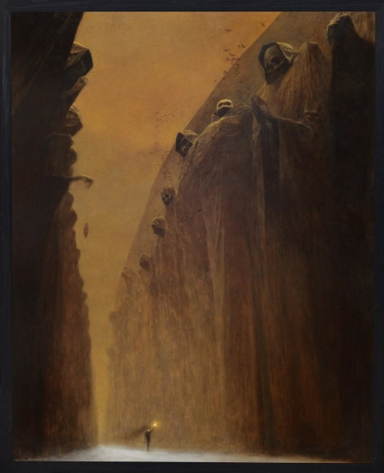

Illustration 1 Beksinski, Zdzislaw (1929-2005) - 1972 Valley of the Dead

1. **Elements**
   * A man
   * A torch
   * Skull Sculptures
   * Bats
   * Red/Brown Sky
   * An abyss or a Valley
2. **Description**

In the imagen we can saw a valley or an abyss, with some skull sculptures with hoods. One of them look like he was praying, and other hold something, like an amulet. There are some bats at the top of sculptures. And at the bottom, there is a man with a torch, walking in the middle of all.

1. **Interpretation**

What I see in this imagen is the passing of a man through his destiny and the complications of his travel to get his goal. The painter draws this picture because his dream this parade in one of his night terror, so maybe this has a darker background. Also, I think that in this abyss there is something dangerous, or the abyss represents some special to the locals or for the dream.

1. **Feelings**

When I saw this imagen, the first sensation that I have is a loneliness, that because just there is a man alone. it also makes me feel small, for the size of the man and the size of the abyss that is much bigger.